**Selenium IDE (Integrated Development Environment)** is the simplest tool in the Selenium Suite. It is a Firefox add-on that creates tests very quickly through its record-and-playback functionality. This feature is similar to that of QTP. It is effortless to install and easy to learn.

Because of its simplicity, Selenium IDE should only be used as a prototyping tool, not an overall solution for developing and maintaining complex test suites.

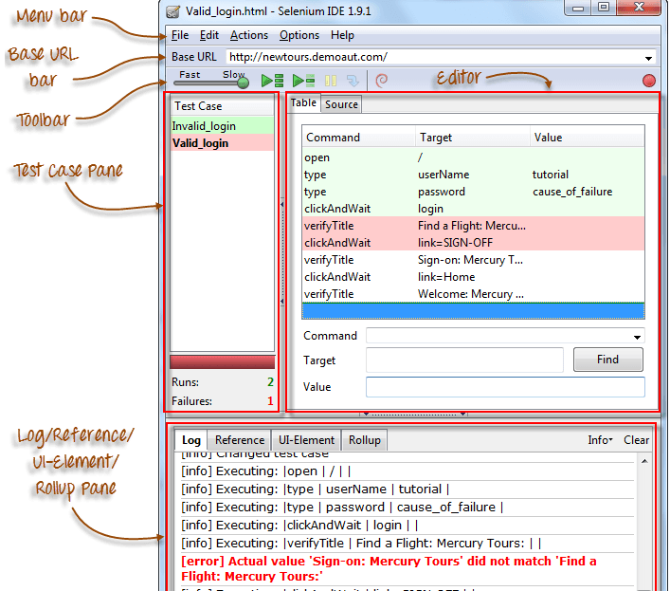

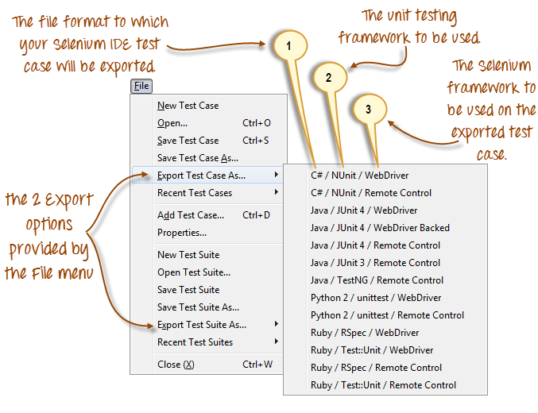 using IDE, can export it to selenium + java, record and play back, run slow / faster.

We specially use to identify hidden some hidden Iframes on screen using IDE.

***************** INSTALLATION *************************

1. Install FF 45
2. Stop auto updates of FF
3. Add fire path and fire bug to FF 45.
4. Add IDE add on

URLS

1. Firebug : <https://addons.mozilla.org/en-US/firefox/addon/firebug/>
2. Firepath : <https://addons.mozilla.org/en-US/firefox/addon/firepath/>
3. IDE : <https://addons.mozilla.org/en-US/firefox/addon/selenium-ide/>

test case is stored in D:\selenium_Class\Selenium\Selenium IDE scripts folder created